1. Go to: [www.anaconda.com/download/](http://www.anaconda.com/download/), and download the python 3.7 version.

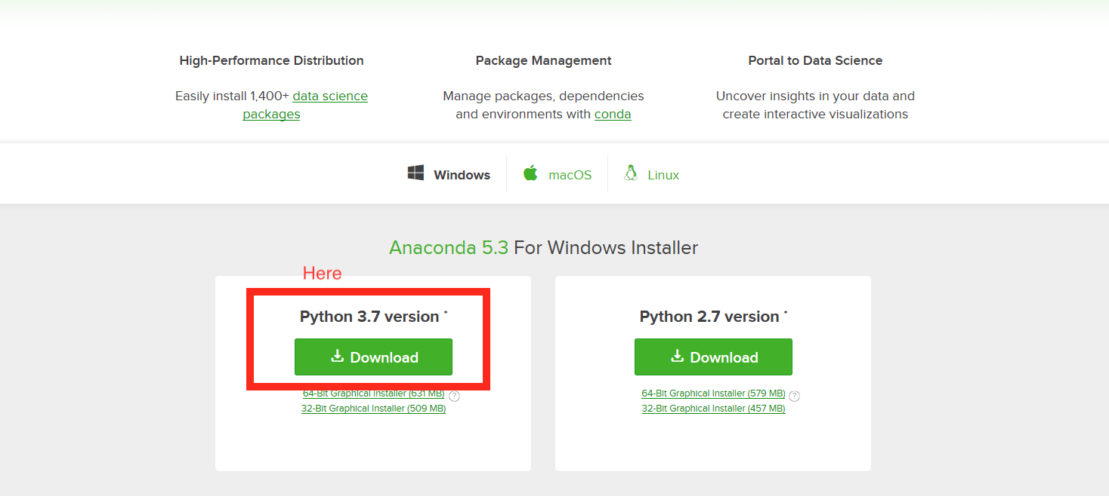

1. Install anaconda. In the installation prompt check “Add Anaconda to my PATH environment variable”.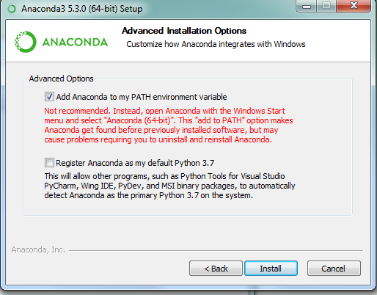
2. Locate the FishRand-master Folder, and unzip it. Then locate “windows_installer.bat”, and double click that. A command prompt window should appear and run multiple commands. (There may be some warning messages, ignore these)

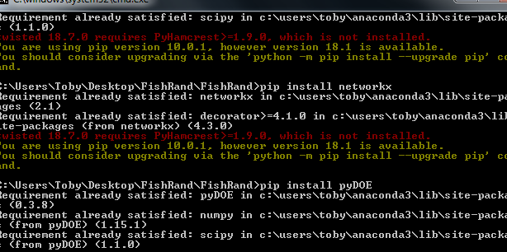

1. Open an other command prompt window, and type “conda install shapley” and hit return. After a while there will be some text asking for a “y/n”. Type “y” and hit return.

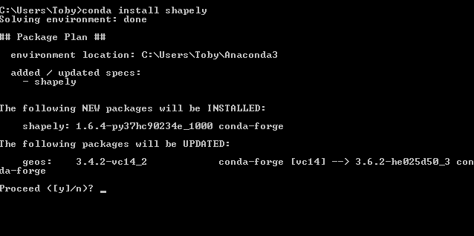

1. From now on just double click on FishRand_windows.bat in the FishRand folder to launch FishRand.

